ATTENDANCE MANAGEMENT
@CREATIVITY THINK (9483175986/7019689991)

ABSTRACT:
Attendance Management is a web application designed to efficiently track daily attendance for students, employees, and event participants. Users can mark attendance, view reports, receive notifications, and export absence records. Administrators manage employees or students, review attendance logs, send alerts, and generate analytics dashboards. Built using Django and Django Rest Framework for backend operations and React with react-table and Axios for frontend interfaces, the system provides a centralized platform for accurate attendance tracking, reporting, and notifications, improving workforce or educational institution management..

INTRODUCTION OF THE PROJECT:
Manual attendance management is time-consuming and prone to errors in organizations, schools, and events. Attendance Management provides a centralized web platform to mark daily attendance, view reports, export absence records, and receive notifications. Administrators can add or manage users, review attendance logs, send alerts, and access dashboards for analytics. Using Django and Django Rest Framework for backend services and React with react-table and Axios for frontend reporting, the platform ensures accurate attendance tracking, timely notifications, and actionable insights for organizational or educational efficiency..

PROJECT OBJECTIVES:

• Enable daily attendance marking for users
• Provide attendance reports and analytics
• Allow export of absence and attendance records
• Send notifications and alerts for irregular attendance
• Enable administrators to add/manage users
• Review logs and track attendance patterns
• Generate dashboards for decision-making

PROBLEM OF THE STATEMENT:
Manual attendance tracking in organizations, schools, and events can lead to errors, delays, and inefficiencies. Tracking absenteeism, generating reports, and notifying concerned individuals are challenging without centralized management. Attendance Management addresses these issues by providing an automated platform where users can mark attendance, view reports, export records, and receive notifications. Administrators gain control to add or manage users, review logs, send alerts, and analyze attendance data efficiently through dashboards, reducing errors and improving organizational productivity..

MOTIVATION OF THE PROJECT:
• Streamline attendance marking for users and admins
• Automate reporting and analytics for better insights
• Enable timely notifications and alerts for absences
• Simplify record export for compliance and tracking
• Provide a centralized dashboard for attendance management

BLOCK DAIGRAM OF PROJECT:

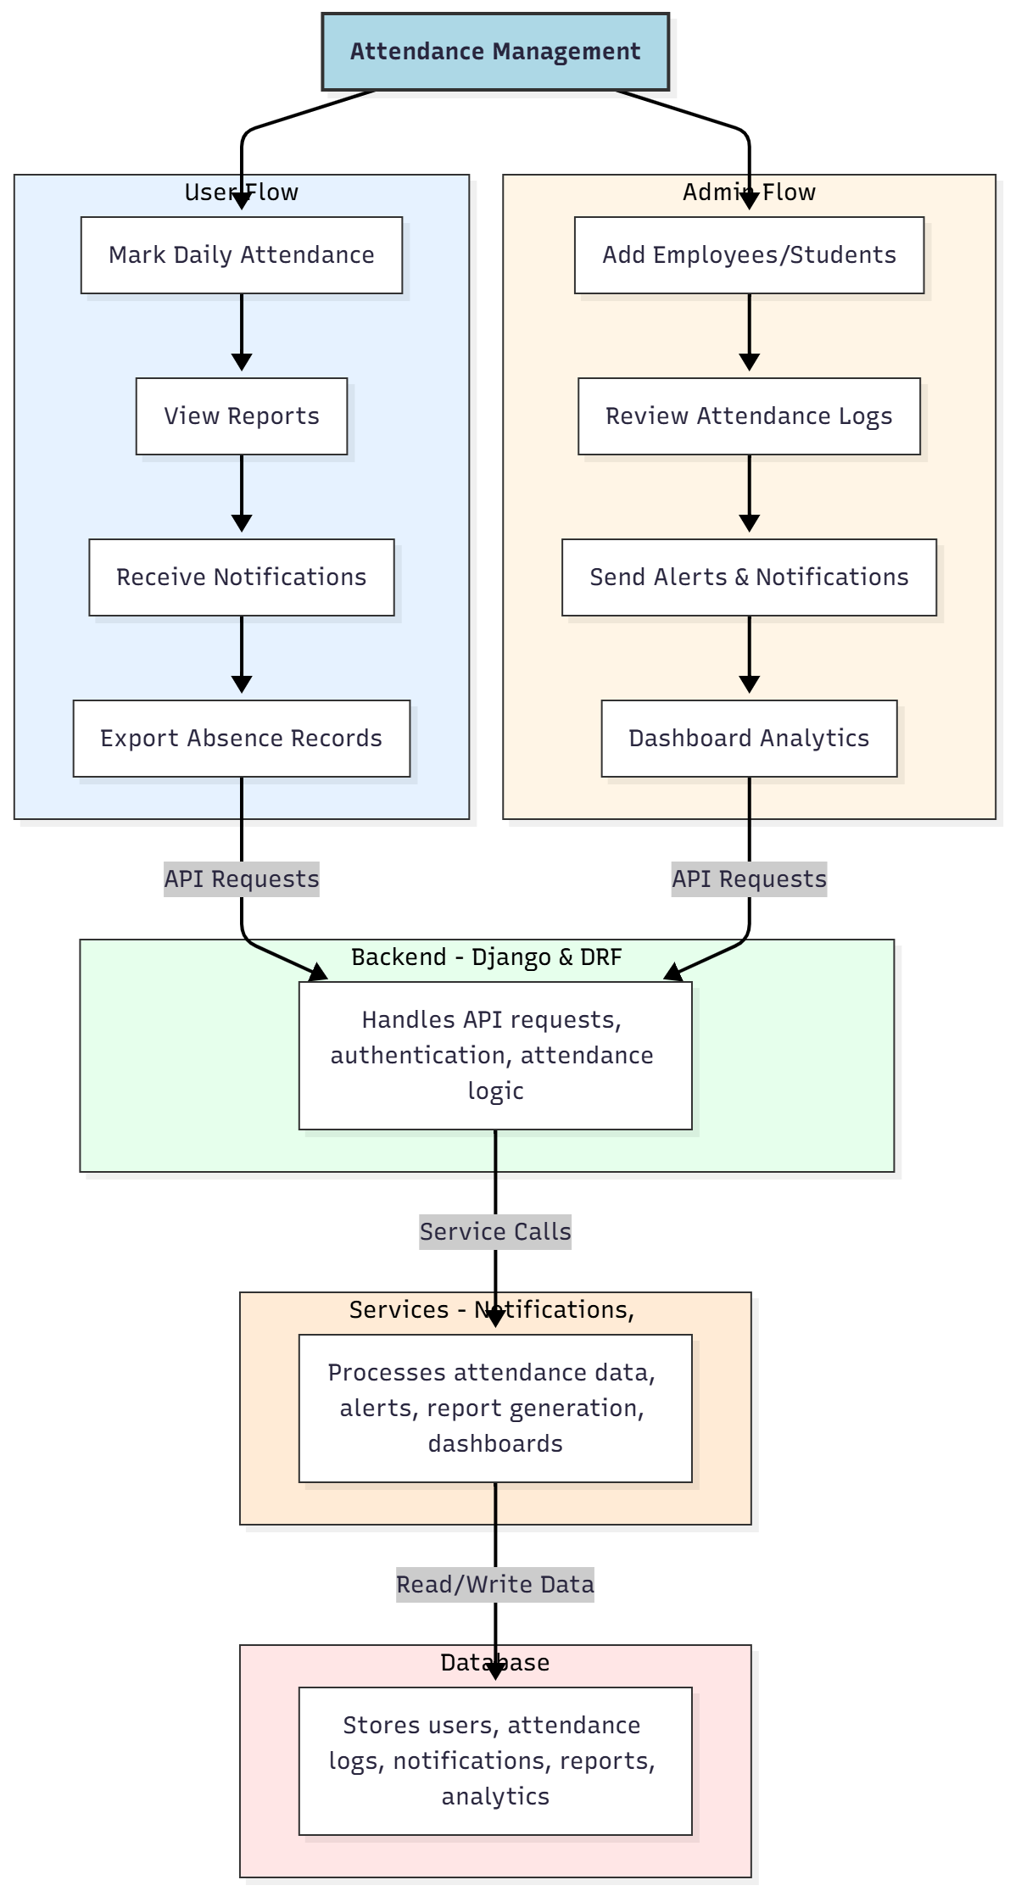

WORKING OF THE PROJECT:
Users mark daily attendance, view attendance reports, receive notifications for absences, and export attendance or absence records. The backend handles API requests, authentication, and attendance logic. Services manage notifications, report generation, and dashboard analytics. Administrators add or manage employees or students, review logs, send alerts, and access analytics dashboards. This system ensures efficient attendance tracking, reduces manual errors, provides timely alerts, and supports organizational and educational management through centralized dashboards..

SOFTWARE REQUIREMENT:
- Backend:
  - Python 3.x
  - Django
  - Django REST Framework
  - SQLite/PostgreSQL
- Frontend:
  - Node.js and npm
  - React.js
  - Axios
- Development Tools:
  - Visual Studio Code
  - Postman (for testing APIs)
  - Git/GitHub (for version control)
- Server/Deployment (Optional):
  - Gunicorn, Nginx, or Heroku/AWS for hosting

ADVANTAGES OF THE PROJECT:

• Accurate daily attendance marking
• Automated report generation and dashboards
• Timely alerts for absences or irregular attendance
• Exportable attendance and absence records
• Centralized management for administrators
• Reduces manual errors and time consumption
• Supports workforce or student monitoring
• Enhances organizational productivity and compliance

APPLICATIONS OF THE PROJECT:
• Employee workforce management
• School and college attendance tracking
• Event or seminar participant tracking
• Reporting and analytics for HR and academic institutions
• Notifications and alerts for absenteeism
• Centralized dashboard for administrators
• Exportable attendance records for audits
• Automated daily attendance systems

REFERENCES:

- Django REST Framework Documentation — Django Software Foundation. Django Documentation. Available: https://docs.djangoproject.com/
- Django REST Framework. DRF Documentation. Available: https://www.django-rest-framework.org/
- React. React Official Documentation. Available: https://reactjs.org/docs/getting-started.html
- Redux. Redux Documentation. Available: https://redux.js.org/introduction/getting-started
- PostgreSQL Global Development Group. PostgreSQL Documentation. Available: https://www.postgresql.org/docs/
- MySQL. MySQL Reference Manual. Available: https://dev.mysql.com/doc/
- Git. Git Documentation. Available: https://git-scm.com/doc
- Node.js. Node.js Documentation. Available: https://nodejs.org/en/docs/
- Axios. Axios Documentation. Available: https://axios-http.com/docs/intro
- Socket.io Documentation – https://socket.io/docs/

